Polytan celebrates 50th birthday at FSB 2019
Sustainable sports surfaces in focus
Never before has a visit to Polytan’s stand at the FSB show been so exciting: the leading manufacturer of sports surfaces for outdoor use will be unveiling a host of impressive product innovations right on time for the company’s 50th birthday. At the heart of the presentation will be its pioneering Green Technology range, in which the expert in synthetic turf systems, synthetic surfaces and soft-impact surfaces is bundling particularly eco-friendly products. They include a world first in the synthetic football turf sector which looks set to be particularly welcomed by amateur clubs, schools and local authorities with high sustainability requirements.
How eco-friendly can modern high-tech sports surfaces made from synthetic material get? Keen to give real impetus to the development of sustainable sports surface systems including infill, two years ago Polytan brought the Green Technology range into life, expanding it in stages. The manufacturer is showcasing four such products at this year's FSB. They include the Poligras Tokyo GT hockey turf, which was developed back in 2017 with an eye on the 2020 Olympic Games in Tokyo. Bio-based raw material produced in sustainable sugar cane plantations makes up 60 per cent of the synthetic turf fibre made by Polytan. This principle is now also being applied to a new synthetic football turf, the LigaTurf Cross GT. Polytan has also just added the new Fusion GT infill, made of 70 per cent natural material, into its Green Technology portfolio, as well as the PolyBase GT elastic layer. The latter uses an eco-friendly binder, the manufacture of which uses CO₂ as the raw material. Its developers have been nominated for the latest Deutscher Zukunftspreis, a prize for ground-breaking innovation.
Keeping on the sustainability theme, the sports surface specialist appears in the new Forum Recycling of the FSB show, where it presents its ideas for the further processing of worn-out synthetic sports surfaces to the trade.

Captions:
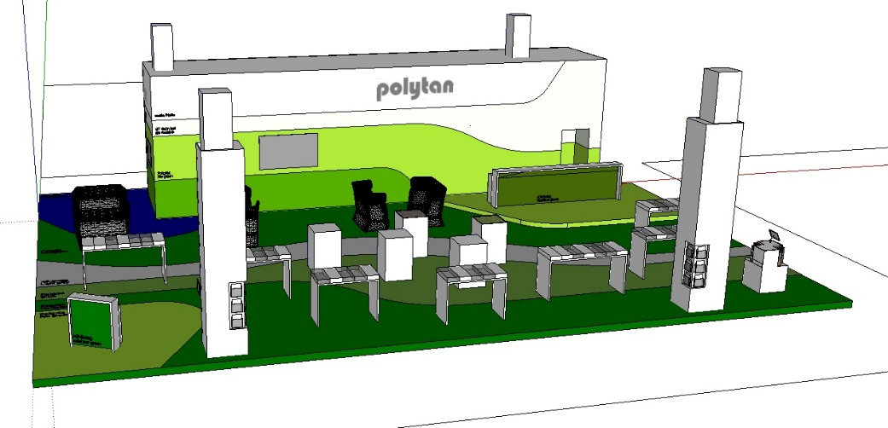
Polytan-Messestand-FSB-2019.jpg
While it all began with synthetic surfaces 50 years ago, Polytan's product range now includes high-speed running tracks, all-weather pitches, tennis and handball courts, soft-impact surfaces as well as synthetic turf systems for football, hockey, rugby and multipurpose pitches. Trade fair highlights in the 2019 special birthday year include four new products offering unique environmental compatibility from the Green Technology range.

Polytan GmbH:
To make the optimal surface for sporting success – that has been the ideal pursued by Polytan since 1969. With a constant eye on the latest findings in the field of sports medicine, the specialist in outdoor sports surfaces is continuously refining its synthetic surfaces and synthetic turf systems. Today's synthetic turf pitches not only feel like real grass, for example, they also have excellent playing qualities. High-quality synthetic surfaces now range from shock-absorbing soft-impact surfaces and multi-functional all-weather pitches all the way to high-speed surfaces for international athletics events. As well as developing, manufacturing and fitting its own sports surfaces, the spectrum of services provided by Polytan also includes line markings, repairs, cleaning and maintenance. All products meet current national and international standards and are duly certified by international sports federations such as FIFA, FIH, World Rugby and IAAF.

Agency contact:
Seifert PR GmbH (GPRA)
Barbara Mäurle
Zettachring 2a
70567 Stuttgart
0711 / 77918-26
barbara.maeurle@seifert-pr.de

Company contact:
Polytan GmbH
Tobias Müller
Gewerbering 3
86666 Burgheim
08432 / 8771
tobias.mueller@polytan.com

