Fast hockey turf made from renewable raw material
World's first Poligras Tokyo GT for Crefelder HTC
Poligras Tokyo GT is the name of the new synthetic turf system for hockey that has been developed by Polytan as official Global Supplier to the FIH (International Hockey Federation) for the 2020 Olympic Games in Tokyo. Not only is the dark-blue playing field faster than ever before, but the turf fibres also consist predominantly of a bio-based synthetic from Braskem. The hockey players at Crefelder HTC are delighted with the world's first Poligras Tokyo GT, which was installed at the Gerd Wellen hockey facility in Krefeld in September 2018.
Crefelder Hockey und Tennis Club 1890 e. V. (Crefelder HTC for short) has nearly 600 active hockey players and is one of the most successful hockey clubs in Germany. The men's field hockey first team has played continuously in the top division since 2001, for example, winning the German championships in the 2005/2006 season and the European Cup Winners' Cup in 2006/2007.
Top-flight hockey tournaments are regularly held at the club's own Gerd Wellen hockey facility, the most recent one being the German Field Hockey Championships (FINAL FOUR 2018) in June. The club, the city and the state have jointly invested around 500,000 euros in a new hockey pitch to ensure that the next round of the FINAL FOUR 2019 is also a resounding success in May – and, of course, because, the existing Sidney synthetic turf had become outdated and worn after 15 years.
Poligras Tokyo GT, which has been developed by Polytan with a view to the 2020 Olympic Games in Japan, was the system of choice for the new pitch. Club manager Robert Haake on the new synthetic turf: "Poligras Tokyo GT is currently the best hockey turf in the world and we are delighted to be the first ever venue where it has been installed." What's more, he anticipates that the blue base will exert a strong pull on other teams. "We expect that many national teams will want to hold training sessions at our facility," continues Haake. Two more pitches with a Poligras Tokyo GT system are planned and completed in Mönchengladbach and China respectively.
Forward-looking investment in its sports facilities is a long-standing tradition at Crefelder HTC. The first synthetic pitch was installed as early as 1990 and it has since been replaced twice – in 2003 and 2018. When Poligras Tokyo GT was installed in 2018, the shock-absorbing base had finally worn out after 28 years and it was replaced with a 35 mm thick PolyBase GT elastic layer. PolyBase GT stands out for its high level of environmental compatibility – as does the Poligras Tokyo GT synthetic turf system. This is denoted by the code GT, which stands for the new GT Green Technology label.
The Poligras Tokyo GT turf achieves a better environmental balance by using the bio-based plastic I’m greenTM by Braskem, the world market leader in this field. Renewable raw materials make up 60 per cent of the polyethylene (PE) base material for the filaments. It is possible to increase this proportion to 100 per cent PE base material, but at a higher cost. As was shown during testing, not only does the new material improve the eco-balance of the synthetic turf, it also optimises the playing qualities of the surface: the ball roll distance increases by up to 25 per cent compared with the predecessor product. This promises to make games of hockey even faster and more dynamic, with even more precise moves.
The PolyBase GT elastic layer is the most recent arrival in the Green Technology product family of Polytan. The product PolyBase GT owes its sustainability to a newly developed binder for the permanently elastic bonding of granules whose manufacture produces lower CO₂ emissions.
Quite apart from the ecological aspects and improved playing qualities, the blue colour of the new Poligras Tokyo GT synthetic hockey pitch in Krefeld is also a winner. The blue playing surface has been all but standard practice at top-flight hockey competitions since the 2012 Olympic Games in London. It sharpens the contrast with the yellow hockey ball and makes it easier to follow the progress of play. This benefits players, spectators and, above all, television viewers. Crefelder HTC has even designed a playing field that exceeds the required dimensions of 100 x 60 yards (91.4 x 55 m) for the purposes of television coverage, which means LED perimeter systems can also be set up for television broadcasts.
Captions:
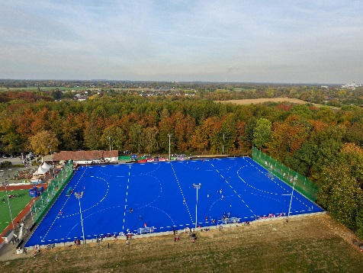 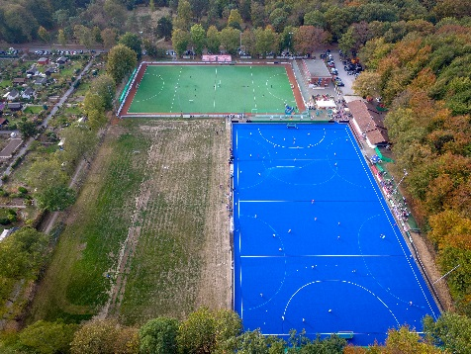
CHTC Krefeld_Poligras Tokyo GT (1).jpg
The pitch at the Gerd Wellen hockey facility of Crefelder HTC was the first one in the world to be fitted with a Poligras Tokyo GT system – a hockey turf that has been developed by Polytan for the 2020 Olympic Games in Tokyo.
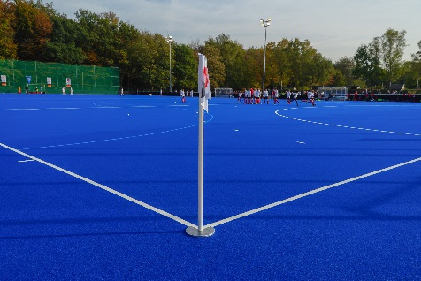
CHTC Krefeld_Poligras Tokyo GT (6).jpg
The blue surface makes it far easier to see the yellow hockey ball than a green one. This is a particular advantage during television coverage, which is why it is all but standard for international hockey events.
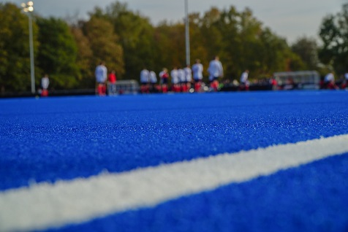
CHTC Krefeld_Poligras Tokyo GT (5).jpg
Although the new Polytan Poligras Tokyo GT synthetic turf is manufactured mainly from bio-based plastic, its performance is better than ever in terms of speed and precision.

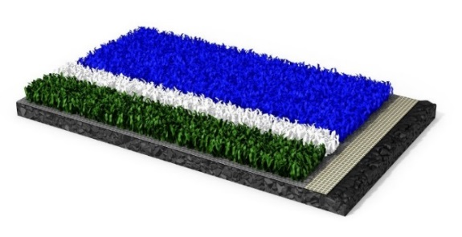
Polytan_Poligras_Tokyo GT.jpg (photo: Polytan)
The new hockey turf Poligras Tokyo GT impresses both with its excellent playing qualities and its environmental compatibility: for the first time, a bio-based synthetic from Braskem accounts for more than 60 per cent of the filament material.
Polytan_GT_Green_Technology.jpg (photo: Polytan)
All Polytan products noted for their sustainability are marked with the new GT Green Technology label.

Polytan GmbH:
To make the optimal surface for sporting success – that has been the ideal pursued by Polytan since 1969. With a constant eye on the latest findings in the field of sports medicine, the specialist in outdoor sports surfaces is continuously refining its synthetic surfaces and synthetic turf systems. Today's synthetic turf pitches not only feel like real grass, for example, but they also have excellent playing qualities. High-quality synthetic surfaces now range from shock-absorbing soft-impact surfaces and multi-functional all-weather pitches all the way to high-speed surfaces for international athletics events. As well as developing, manufacturing and fitting its own sports surfaces, the spectrum of services provided by Polytan also includes line markings, repairs, cleaning and maintenance. All products meet current national and international standards and are duly certified by international sports federations such as FIFA, FIH, World Rugby and IAAF.

About Braskem:
With a human-oriented global vision of the future, Braskem strives every day to improve people’s lives by creating sustainable solutions with chemicals and plastics. Braskem is the largest producer of thermoplastic resins in the Americas and the leading producer of biopolymers in the world, creating more environmental-friendly, intelligent and sustainable solutions through chemicals and plastics. Braskem exports to clients in approximately 100 countries and operates 41 industrial units, which are located in Brazil, United States, Germany and Mexico, the latter in partnership with the Mexican company Idesa. For more information, visit www.braskem.com.

Agency contact:
Seifert PR GmbH (GPRA)
Barbara Mäurle
Zettachring 2a
70567 Stuttgart
0711 / 77918-26
barbara.maeurle@seifert-pr.de
Company contact:
Polytan GmbH
Tobias Müller
Gewerbering 3
86666 Burgheim
08432 / 8771
tobias.mueller@polytan.com

