New LigaGrass Synergy synthetic turf for clubs and local communities:
50 per cent less rubber granulate infill
Constant product innovations in our own research and development laboratories make it possible for the new generation of LigaGrass Synergy synthetic turf from Polytan to need a further 50 per cent fewer infill granules than its LigaGrass Pro CoolPlus predecessor – which already had a reduced amount of infill – without having to compromise on the highest standards of injury protection for players and the playing qualities of the turf. The Burgheim-based sports surface specialist has been able to reduce the amount of infill required in its synthetic turf systems to approx. 2 kg/m², depending on the respective system design and type of rubber granulate. This is 80 per cent less than the international infill requirement of around 16 kg/m².
The current debate on the discharge of rubber granules from synthetic turf playing fields into the environment means that sports clubs, local authorities and communities are increasingly faced with concerned questions from their members, management boards, sponsors, athletes and parents. As one of the world's leading manufacturers of synthetic turf, Polytan can give the all-clear here – at least with regard to its own synthetic turf systems, which currently represent state-of-the-art technology for synthetic turf pitches in Germany.
Synthetic turf in Germany is not the same as synthetic turf in Europe
Synthetic turf playing fields in Germany differ significantly from the European EN 15330-1 standard in terms of their construction: the German DIN 18035-7 industrial standard stipulates the use of a stable, elastic base layer. The turf laid on top of this has substantially shorter filaments and requires a lower amount of rubber granulate infill at the same time. At Polytan the latter consists of recycled materials, is between 25 and 30 cm thick and has optimal levels of force reduction to protect athletes against injury. It has a minimum lifespan of 30 years.
Crimped filaments: "permanent wave" holds granules in the turf
The use of textured filaments, or stalks with a "permanent wave" as it were, is another way of making sure that less infill material is needed and has been standard practice at Polytan since the early 2000s. Not only are the textured synthetic turf filaments more hardwearing than smooth ones, they also reduce the amount of infill and splash of Polytan synthetic turf systems even further.
All of these attributes come together in the new LigaGrass Synergy. In addition, it has been possible to lower the infill requirement of this new synthetic turf system by 50 per cent within the textured turf, thanks to a higher fibre content and an even denser turf structure.
LigaGrass Synergy with innovative MultiTuft technology
With the newly developed MultiTuft technology, Polytan has for the first time succeeded in combining two textured filaments of different shapes and fineness to form an optimal complete system. A multitude of soft and flexible Synergy filaments are combined with the larger and firmer LigaGrass Pro filaments in this process. As a result, the infill is held more firmly in place in the turf without having to compromise on traction and rotation.
Info box:
The filling quantities of sand and rubber granules are reduced by 50 per cent with LigaGrass Synergy – from approx. 4 kg/m² with LigaGrass Pro (with EPDM ST infill) to approx. 2 kg/m² with the new LigaGrass Synergy (with Fusion GT infill). Note: This amount is around 16 kg/m² for synthetic turf filled in accordance with European standards, i.e. eight times as much.
Apart from the use of a durable elastic layer and textured filaments, the Fusion GT granules also help to reduce the infill requirements of the new LigaGrass Synergy synthetic turf system from Polytan. This new EPDM rubber granulate product is a combination of natural and fast-growing renewable raw materials and was brought to market by Polytan in 2017. The almost natural shape of the granules reduces the bulk density of the material – and hence the material requirements – at the same time.
LigaGrass Synergy – making clubs and communities fit for the future
The high wear resistance, low maintenance costs and natural grass appearance of LigaGrass Pro synthetic turf make it the ideal system for clubs and communal facilities. Its successor, LigaGrass Synergy, has an even lower infill requirement of just 2 kg/m², making it fit for the future from an ecological perspective as well while also guaranteeing the same level of player protection and comfort.
And for those who would prefer it, there is always the option of doing without any synthetic fillers: the new LigaGrass Synergy is also available from Polytan as a purely sand-filled version.

Captions:
Picture credits: Polytan GmbH
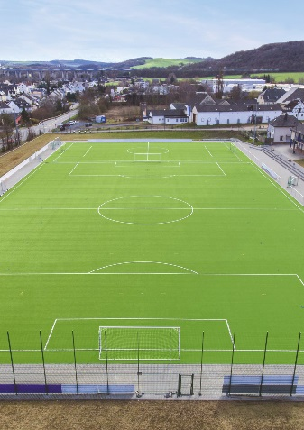
LigaGrass Synergy_01jpg
Hardwearing, easy to maintain, multifunctional – and with the lowest ever rubber granulate infill requirement of just 2 kg/m². That makes the new LigaGrass Synergy synthetic turf system ideal for clubs and local communities.

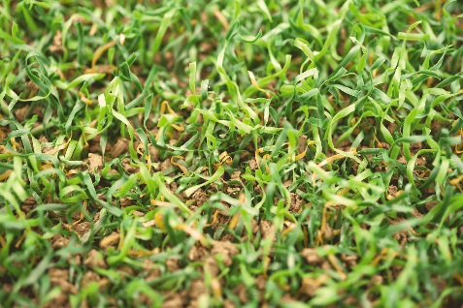
LigaGrass Synergy_02jpg
Textured filaments – i.e. grass stalks with a "permanent wave" – hold the rubber granules firmly in place and significantly reduce discharge into the environment.
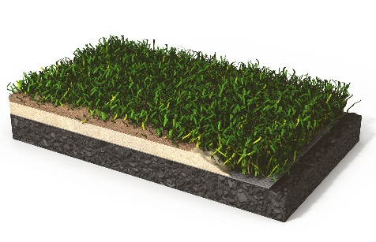
LigaGrass Synergy_03jpg
Standard structure of a synthetic turf system in Germany: the stable elastic layer and the shorter filaments reduce the quantity of rubber granules needed as infill by over 60 per cent.

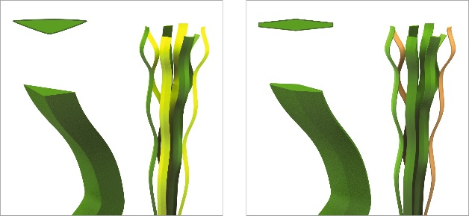
LigaGrass Synergy_04jpg
Left: the firmer LigaGrass Pro filaments; right: the soft and flexible Synergy filaments. The TriColour scheme also gives the turf a natural look.
Polytan GmbH:
To make the optimal surface for sporting success – that has been the ideal pursued by Polytan since 1969. With a constant eye on the latest findings in the field of sports medicine, the specialist in outdoor sports surfaces is continuously refining its synthetic surfaces and synthetic turf systems. Today's synthetic turf pitches not only feel like real grass, for example, but they also have excellent playing qualities. High-quality synthetic surfaces now range from shock-absorbing soft-impact surfaces and multi-functional all-weather pitches all the way to high-speed surfaces for international athletics events. As well as developing, manufacturing and fitting its own sports surfaces, the spectrum of services provided by Polytan also includes line markings, repairs, cleaning and maintenance. All products meet current national and international standards and are duly certified by international sports federations such as FIFA, FIH, World Rugby and IAAF.

Agency contact:
Seifert PR GmbH (GPRA)
Barbara Mäurle
Zettachring 2a
70567 Stuttgart
0711 / 77918-26
barbara.maeurle@seifert-pr.de

Company contact:
Polytan GmbH
Tobias Müller
Gewerbering 3
86666 Burgheim
08432 / 8771
tobias.mueller@polytan.com

