‘WE MAKE SPORT’:
Polytan to promote sustainability at FSB

Polytan, Germany’s market leader in artificial sports surfaces, will once again be taking part in the International Trade Fair of Amenity Areas, Sports and Pool Facilities (FSB) this year, scheduled to run from 26th to 29th October in Cologne.

Polytan’s exhibit will be titled “WE MAKE SPORT” and will showcase the company’s entire product range and numerous innovations.
The company’s sustainability strategy will take centre stage at the trade fair. At last year’s FSB, the focus was on various products made from renewable raw materials, like the 100-percent climate-neutral LigaTurf Cross GT^{zero}. This year, Polytan will go a step further by highlighting its many sustainability activities.
One of the crowning achievements has been the closing of the material cycle at Polytan. Thanks to the founding of sister company FormaTurf, Polytan offers customers a highly sustainable recycling option – almost 100 percent of a synthetic turf pitch can now be recycled and transformed into new products or, in the case of infill sand, washed and reused on other sports surfaces. As a result, Polytan now provides fully recyclable artificial pitches from the start of their lifecycles to the very end: from the research and development stages through to production and installation and finally on to removal and recycling.
Visitors to the Polytan exhibit at FSB will also be introduced to the numerous innovative artificial turf and sports surfaces products in the Polytan brand universe. Here too, sustainability plays a central role as the company continues to steadily develop its Green Technology strategy.
Polytan can be found at the Koelnmesse in Hall 10.1, Stand C010/DO11. We look forward to your visit!

Image captions:

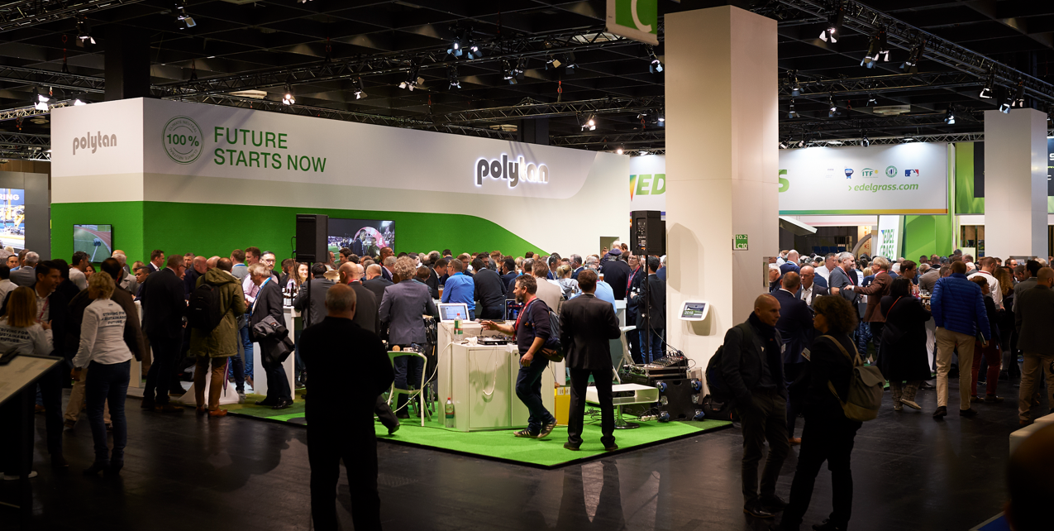
Polytan@FSB2019.jpg
Germany’s market leader in sports surfaces, Polytan, will once again take part in the International Trade Fair of Amenity Areas, Sports and Pool Facilities (FSB), from 26th to 29th October 2021 in Cologne.

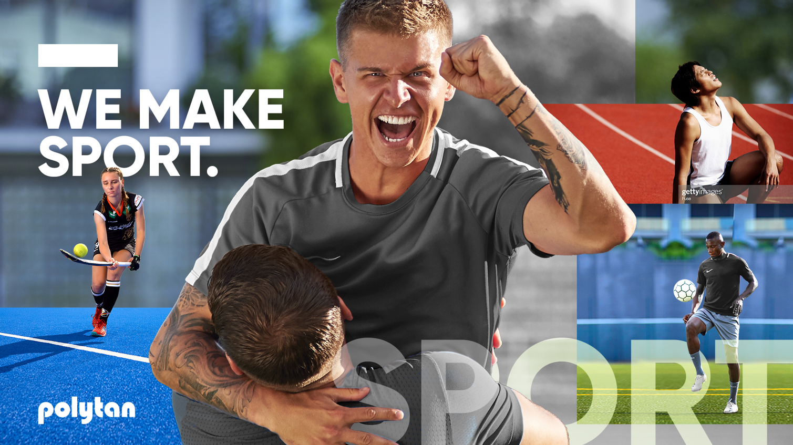
POLYTAN_WE_MAKE_SPORT.jpg
Germany’s leading system providers of sports surfaces, Polytan, will present its complete product range and numerous innovations under the slogan “WE MAKE SPORT.”

Polytan GmbH:
Since 1969, Polytan has been committed to providing the perfect surface for athletic achievements. The specialist in outdoor sports surfaces is constantly redeveloping its synthetic sports surfaces and artificial turf systems based on the latest advancements in sports science. Polytan’s artificial turf playing fields have a natural grass feel and optimal playing characteristics. Our high-quality synthetic turfs range from shock-absorbent, soft-impact surfaces to multifunctional all-weather courts and high-speed surfaces for international athletics events. In addition to the development, production and installation of sports surfaces, Polytan’s scope of services also includes painting, repair, cleaning and maintenance. All products comply with current national and international standards and carry all the relevant certificates of international sports federations such as FIFA, FIH, World Rugby and World Athletics.

Agency contact: | Company contact:
Seifert PR GmbH (GPRA) | Polytan GmbH
Clemens Ottmers | Tobias Müller
Zettachring 2a | Gewerbering 3
70567 Stuttgart | 86666 Burgheim
+49 (0) 711 / 77918-17 | +49 (0) 8432 / 87-71
clemens.ottmers@seifert-pr.de | tobias.mueller@polytan.com

